Jeff Sherard
CSC160C11
7/5/2013

Documentation for Ch06_Ex24 Program

Problem Analysis

Write a program that outputs inflation rates for two successive years and whether the inflation is increasing or decreasing. Ask the user to input the current price of an item and its price one year and two years ago. To calculate the inflation rate for a year, subtract the price of the item for that year from the price of the item one year ago and then divide the result by the price a year ago. Your program must contain at least the following functions: a function to get the input, a function to calculate the results, and a function to output the results. Use appropriate parameters to pass the information in and out of the function. Do not use any global variables.

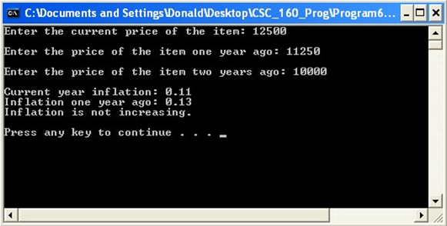

Algorithm

- Define variables:

Input Function
double priceItemYearNow
double priceItemYearOne
double priceItemYearTwo

Calculate Function
double inflationRateNow
double inflationRateOne

Ouput Function
string Current = "Current year inflation: ";
string inflationOne = "Inflation one year ago: ";
string increaseInflation = "Inflation is increasing.";
string decreaseInflation = "Inflation is decreasing.";

- Get input:
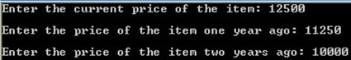

- Calculate:
Function – to get input
Enter the current price of the item:
Enter the price of the item one year ago:
Enter the price of the item two years ago:

Function – to calculate results
inflationRateNow = (priceItemYearNow - priceItemYearOne) / (priceItemYearOne);
inflationRateOne = (priceItemYearOne - priceItemYearTwo) / (priceItemYearTwo);

Function – to output results
Current year inflation: inflationRateNow
Inflation one year ago: inflationRateOne

// decide if inflation rate is increasing, decreasing or staying the same
if ((inflationRateOne - inflationRateNow) == 0)
neutralInflation
else if
((inflationRateOne - inflationRateNow) > 0)
decreaseInflation
else
cout << increaseInflation

Use parameters to pass information in and out of the function

Do not use any global variables

- Output:
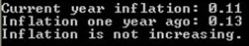

User Documentation

To run the program the user will double click Ch4_Ex14.exe located on the C drive. After the program has loaded and the design is displayed, the user will be prompted to, “Press any key to continue…” which will terminate the program. Output will be displayed on the screen.

